S_ALR_87003642 -

Functionality
In this activity you specify for each variant which posting periods are open for posting. Two intervals are available for doing this (period 1 and period 2). For every interval, enter a lower period limit, an upper period limit and the fiscal year.
You can specify separately G/L account number ranges (as well as sub ledger accounts). To do this, you specify the subledger account type, such as D or K, and the corresponding reconciliation account.
In this way you can, for instance, close postings for customer accounts, but allow postings for vendors and GL accounts.

Scenario
At month end, after Assets, AP, AR and GL ledgers are ready to be closed, maintain this transaction accordingly. Specify the periods allowed for posting.

Requirements
None

Menu Path | Accounting → Financial Accounting → General Ledger → Environment → Current Settings → S_ALR_87003642 - Open and Close Posting Periods
Transaction Code | S_ALR_87003642

1. Double click on S_ALR_87003642 - Open and Close Posting Periods

Change View "Posting Periods: Specify Time Intervals": Overview

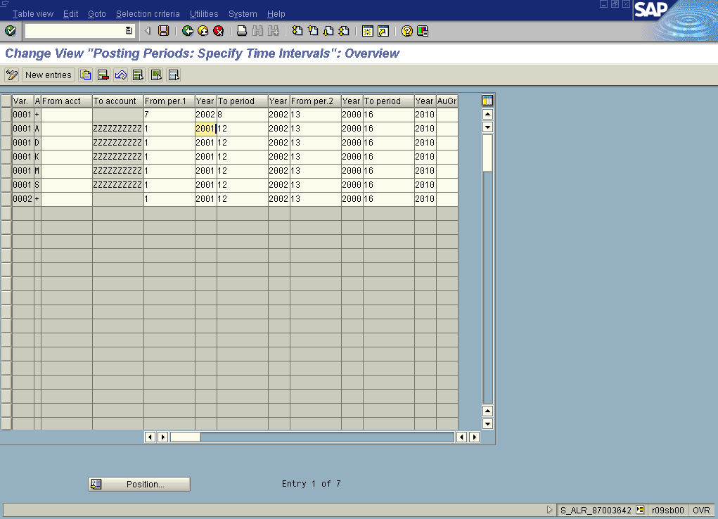

2. To allow postings for all types of accounts (including sub ledgers) in July and August 2002 point a cursor in the row 001.
3. Update the following fields:

Field Name | Field Description | Values
From per. 1 | First Posting Period Allowed (in Interval 1) | Example: 7
To period | Last Posting Period Allowed (in Interval 1) | Example: 8

4. Click Enter Button to confirm your entries.
5. To update the database, click Save Button .
6. The message bar displays “Data saved”

